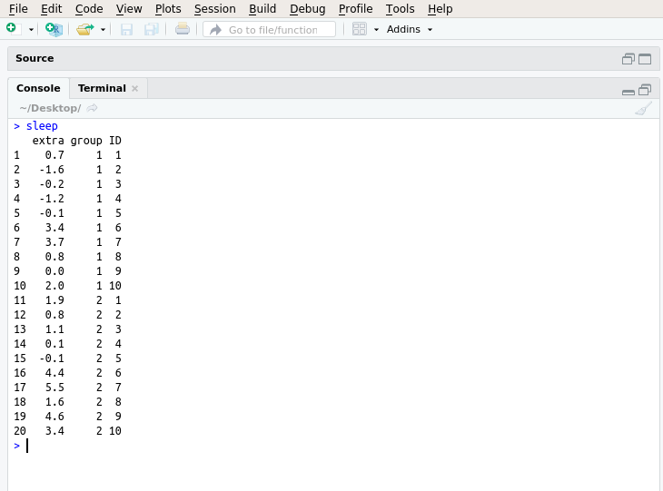

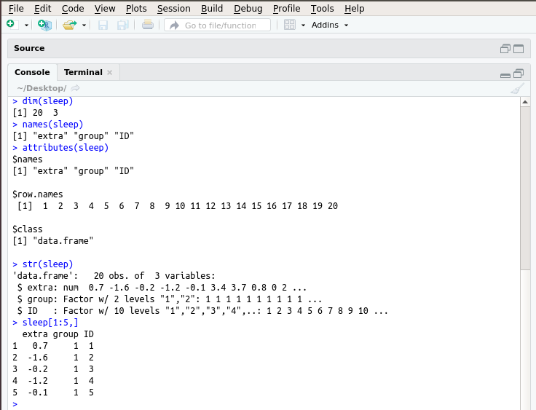

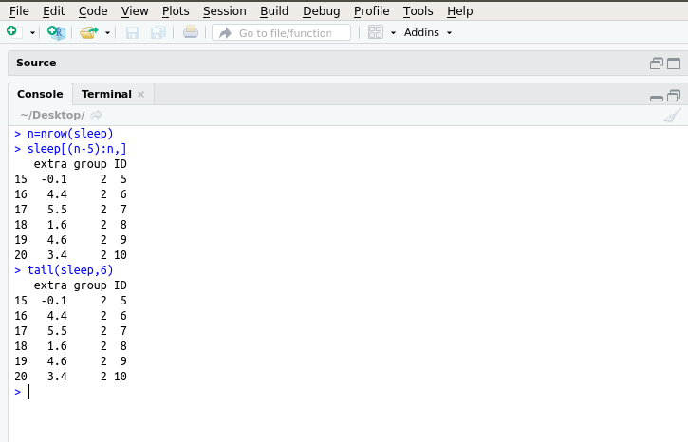

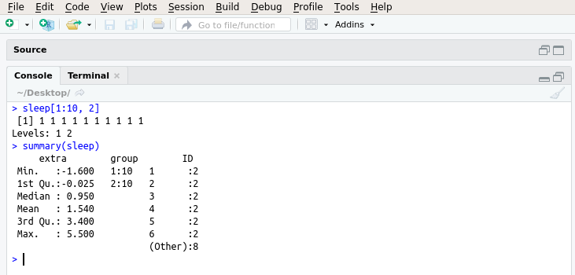

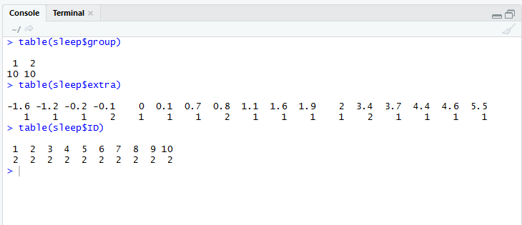

>pie(table(sleep$ID),col=c('red','blue','green','yellow'), labels= NULL, main="sleep piechart")

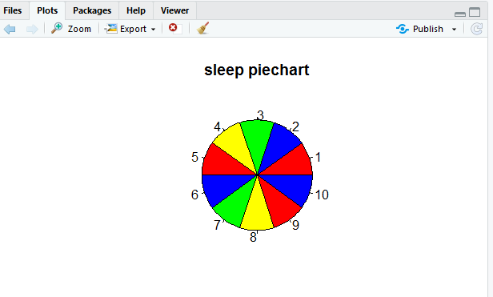

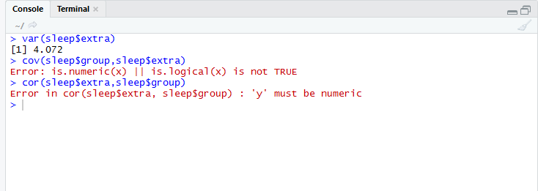

>hist(sleep$extra,main="Extra hours slept",xlab="X axis",ylab="Y axis",col=c("red","green","blue"))

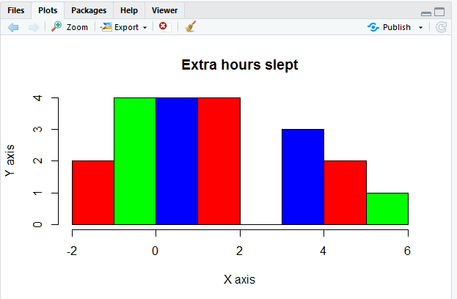

>plot(density(sleep$extra))

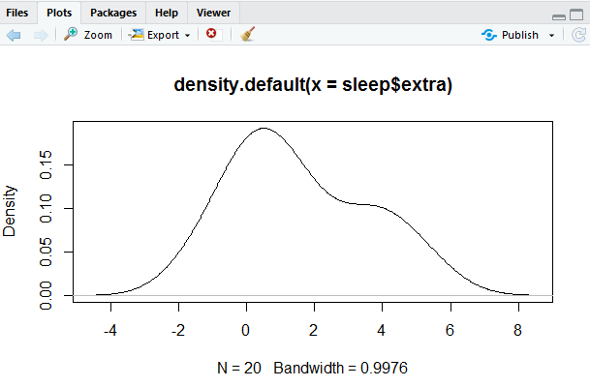

> plot(sleep$extra,sleep$ID, main="Scatter plot of sleep", xlab = "extra",ylab = "ID",pch=8)

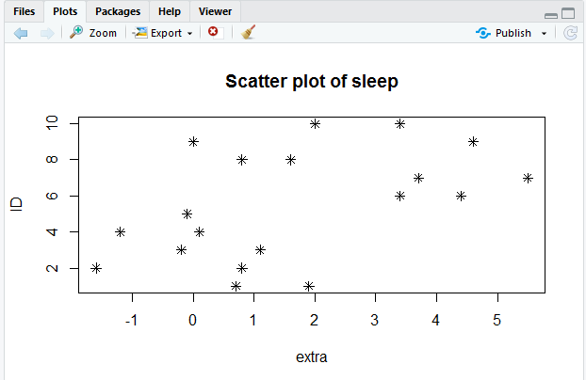

>plot(sleep)

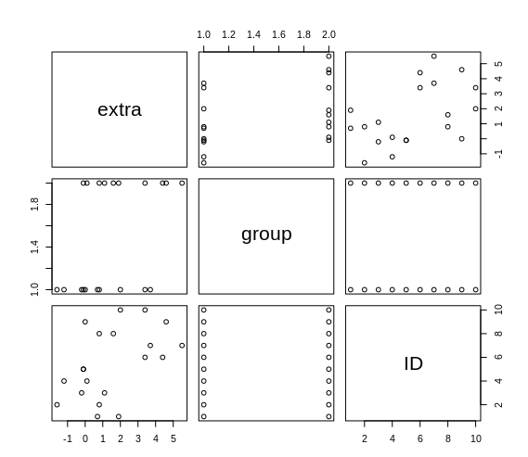

> boxplot(sleep$extra,main="Box Whisker plot", xlab="extra hours", horizontal = TRUE)

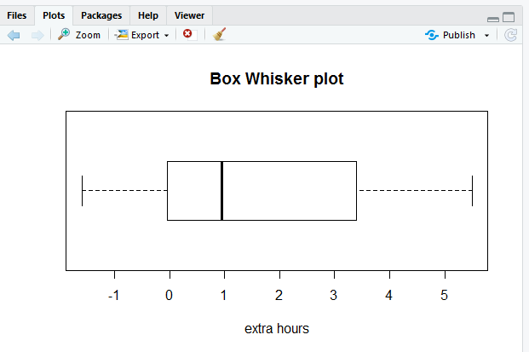

> plot(sleep$extra,main="Numeric line chart", xlab = "Index", ylab = "extra", type= "l")

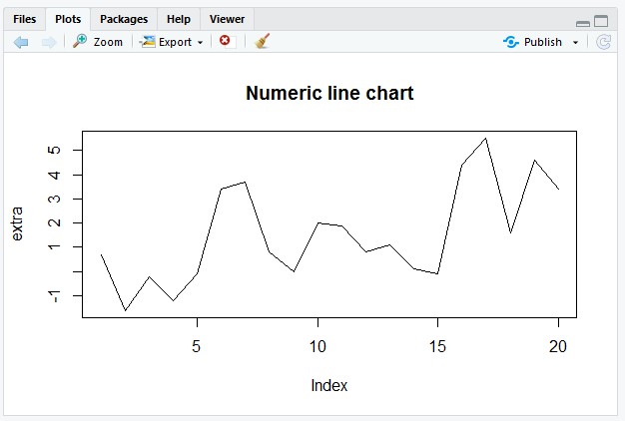

> dotchart(sleep$extra,color = "blue", pch=18, main='Cleveland Dot Chart', xlab="ID")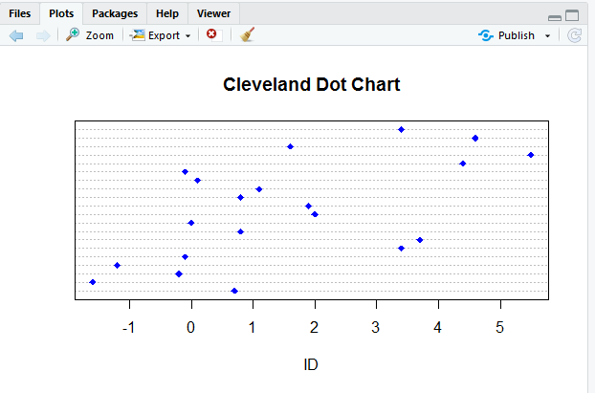

>barplot(sleep$extra, main="Barplot", xlab = "Index", ylab = "group", col = "red", border = "blue")

